GeckoDriver Installation
Step 1: Check Firefox Version
firefox --version
Example Output: Mozilla Firefox 147.0.3
If Firefox is not installed:
sudo apt install firefox
Step 2: Download GeckoDriver
LATEST_GECKO=$(curl -s https://api.github.com/repos/mozilla/geckodriver/
releases/latest | jq -r '.tag_name')
wget https://github.com/mozilla/geckodriver/releases/download/
$LATEST_GECKO/geckodriver-$LATEST_GECKO-linux64.tar.gz
This fetches the latest GeckoDriver version and downloads it.
Step 3: Extract the File
tar -xvzf geckodriver-$LATEST_GECKO-linux64.tar.gz
Step 4: Move GeckoDriver to System Path
sudo mv geckodriver /usr/local/bin/
Step 5: Give Execute Permission
sudo chmod +x /usr/local/bin/geckodriver
Step 6: Verify Installation
geckodriver --version
Example Output: geckodriver 0.36.0 (a3d508507022 2025-02-24 15:57 +0000)

Program 6: Maven Selenium Project – Multi-Tab Automation Using Firefox Browser (GeckoDriver)
Websites Used
Tab | Website | Action
Tab 1 | https://automationexercise.com/ | Remove ads, scroll and click product
Tab 2 | https://practicetestautomation.com/practice-test-login/ | Login with student credentials
Tab 3 | https://www.saucedemo.com/ | Login with standard_user credentials

Project Creation Procedure
Step 1: Create Maven Project
mvn archetype:generate -DgroupId=com.example -DartifactId=MyMavenSeleniumFirefox
-DarchetypeArtifactId=maven-archetype-quickstart -DinteractiveMode=false
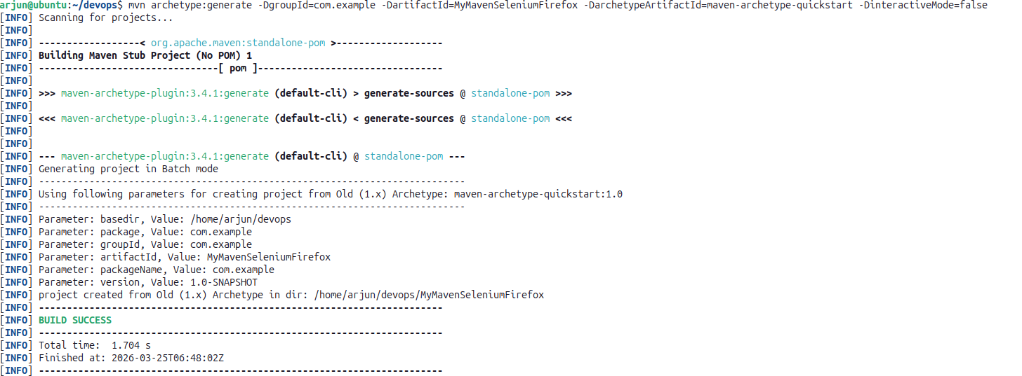

Step 2: Navigate to the Project Directory
cd MyMavenSeleniumFirefox
tree

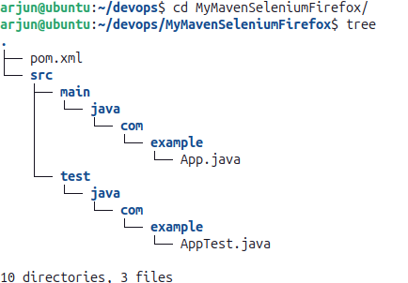

Step 3: Edit pom.xml
gedit pom.xml
pom.xml
<project xmlns="http://maven.apache.org/POM/4.0.0"
xmlns:xsi="http://www.w3.org/2001/XMLSchema-instance"
xsi:schemaLocation="http://maven.apache.org/POM/4.0.0
http://maven.apache.org/maven-v4_0_0.xsd">
<modelVersion>4.0.0</modelVersion>
<groupId>com.example</groupId>
<artifactId>MyMavenSeleniumApp01</artifactId>
<packaging>jar</packaging>
<version>1.0-SNAPSHOT</version>
<name>MyMavenSeleniumApp01</name>
<url>http://maven.apache.org</url>
<dependencies>
<dependency>
<groupId>junit</groupId>
<artifactId>junit</artifactId>
<version>3.8.1</version>
<scope>test</scope>
</dependency>
<!-- Selenium: Browser automation library -->
<dependency>
<groupId>org.seleniumhq.selenium</groupId>
<artifactId>selenium-java</artifactId>
<version>4.29.0</version>
</dependency>
</dependencies>
<build>
<plugins>
<plugin>
<groupId>org.apache.maven.plugins</groupId>
<artifactId>maven-compiler-plugin</artifactId>
<version>3.8.1</version>
<configuration>
<source>1.7</source>
<target>1.7</target>
</configuration>
</plugin>
<plugin>
<groupId>org.apache.maven.plugins</groupId>
<artifactId>maven-surefire-plugin</artifactId>
<version>2.22.2</version>
</plugin>
<plugin>
<groupId>org.apache.maven.plugins</groupId>
<artifactId>maven-jar-plugin</artifactId>
<version>3.0.1</version>
<configuration>
<archive>
<manifestEntries>
<Main-Class>com.example.App</Main-Class>
</manifestEntries>
</archive>
</configuration>
</plugin>
</plugins>
</build>
</project>

Step 4: Inspect Elements on All Three Websites
Open each website in Firefox. Right-click → Inspect. Use cursor tool to identify all form fields and buttons as listed in the HTML Elements table above.
Step 5: Modify App.java
cd src/main/java/com/example/
gedit App.java
App.java
package com.example;
import org.openqa.selenium.By;
import org.openqa.selenium.WebDriver;
import org.openqa.selenium.Dimension;
import org.openqa.selenium.JavascriptExecutor;
import org.openqa.selenium.WebElement;
import org.openqa.selenium.firefox.FirefoxDriver;
import org.openqa.selenium.firefox.FirefoxOptions;
import org.openqa.selenium.WindowType;
import org.openqa.selenium.support.ui.WebDriverWait;
import org.openqa.selenium.support.ui.ExpectedConditions;
import java.time.Duration;

public class App {
public static void main(String[] args) throws InterruptedException {

// Configure Firefox options
FirefoxOptions options = new FirefoxOptions();

// Launch Firefox browser
WebDriver driver = new FirefoxDriver(options);
driver.manage().window().setSize(new Dimension(1920, 1080));
System.out.println("Browser started");

// -------- TAB 1: AutomationExercise --------
driver.get("https://automationexercise.com/");
Thread.sleep(3000);
System.out.println("Site 1 loaded");

// Remove iframe advertisements using JavaScript
JavascriptExecutor js = (JavascriptExecutor) driver;
js.executeScript("document.querySelectorAll('iframe').forEach(e => e.remove());");

// Locate and click the first product
WebElement element = driver.findElement(By.cssSelector("a[data-product-id='1']"));
js.executeScript("arguments[0].scrollIntoView(true);", element);
js.executeScript("arguments[0].click();", element);
System.out.println("Clicked product on Site 1");

// -------- TAB 2: PracticeTestAutomation --------
driver.switchTo().newWindow(WindowType.TAB);
WebDriverWait wait = new WebDriverWait(driver, Duration.ofSeconds(20));
driver.get("https://practicetestautomation.com/practice-test-login/");
System.out.println("Site 2 opened");

wait.until(ExpectedConditions.titleContains("Login"));
wait.until(ExpectedConditions.presenceOfElementLocated(
By.id("username"))).sendKeys("student");
driver.findElement(By.id("password")).sendKeys("Password123");
driver.findElement(By.id("submit")).click();
System.out.println("Logged into Site 2");

// -------- TAB 3: SauceDemo --------
driver.switchTo().newWindow(WindowType.TAB);
Thread.sleep(2000);
driver.get("https://www.saucedemo.com/");
Thread.sleep(2000);

driver.findElement(By.id("user-name")).sendKeys("standard_user");
driver.findElement(By.id("password")).sendKeys("secret_sauce");
driver.findElement(By.id("login-button")).click();
System.out.println("Logged into Site 3");

Thread.sleep(5000);
driver.quit();
System.out.println("Browser closed");
}}
Step 6: Compile the Project
mvn clean install
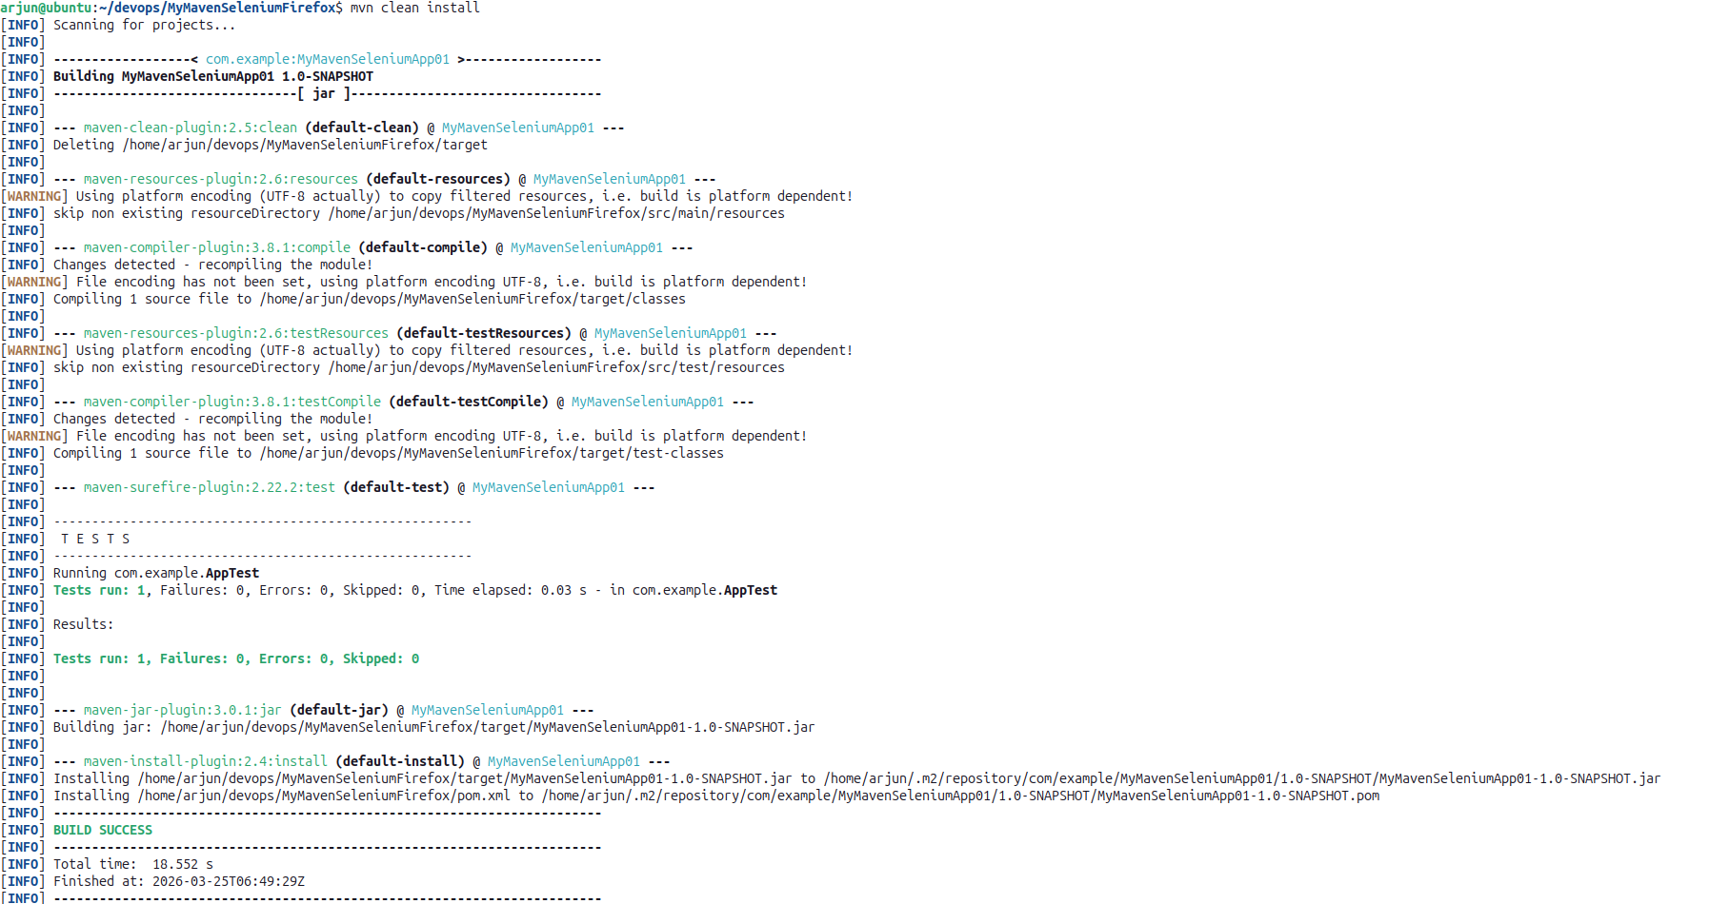

Step 7: Run the Application
mvn exec:java -Dexec.mainClass="com.example.App"

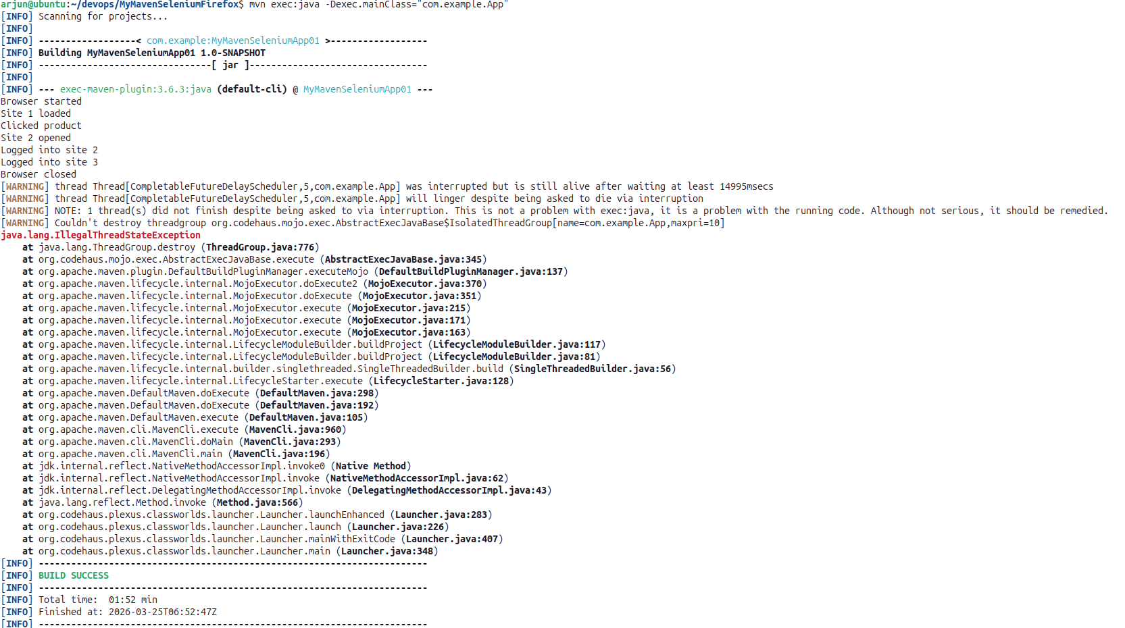

Output
Firefox browser launches and three separate tabs open and execute automatically. Tab 1 opens AutomationExercise, removes ads and clicks the product. Tab 2 opens PracticeTestAutomation and logs in with student credentials. Tab 3 opens SauceDemo and logs in with standard_user credentials.
Browser started
Site 1 loaded
Clicked product on Site 1
Site 2 opened
Logged into Site 2
Logged into Site 3
Browser closed
BUILD SUCCESS

Pushing to GitHub
Step-by-Step Git Command Reference
1. Create a GitHub Repository
Go to GitHub and create a new repository. Ensure the repository name matches your local project directory name. Do not initialize the repository with a README or any additional files.
2. Open Terminal in Your Project Directory
Navigate to your project folder so that it becomes the current working directory.
3. Configure Git Identity
git config --global user.name "username"
git config --global user.email "user_email"
4. Initialize the Repository
git init
5. Stage All Files
git add .
6. Create the First Commit
git commit -m "message"
7. Link to GitHub Remote
git remote add origin "https://github.com/username/repo_name.git"
8. Authenticate with a Personal Access Token
remote set-url origin "https://token@github.com/username/repo_name"
9. Push to GitHub
git push -u origin master

